myDamco User Guide

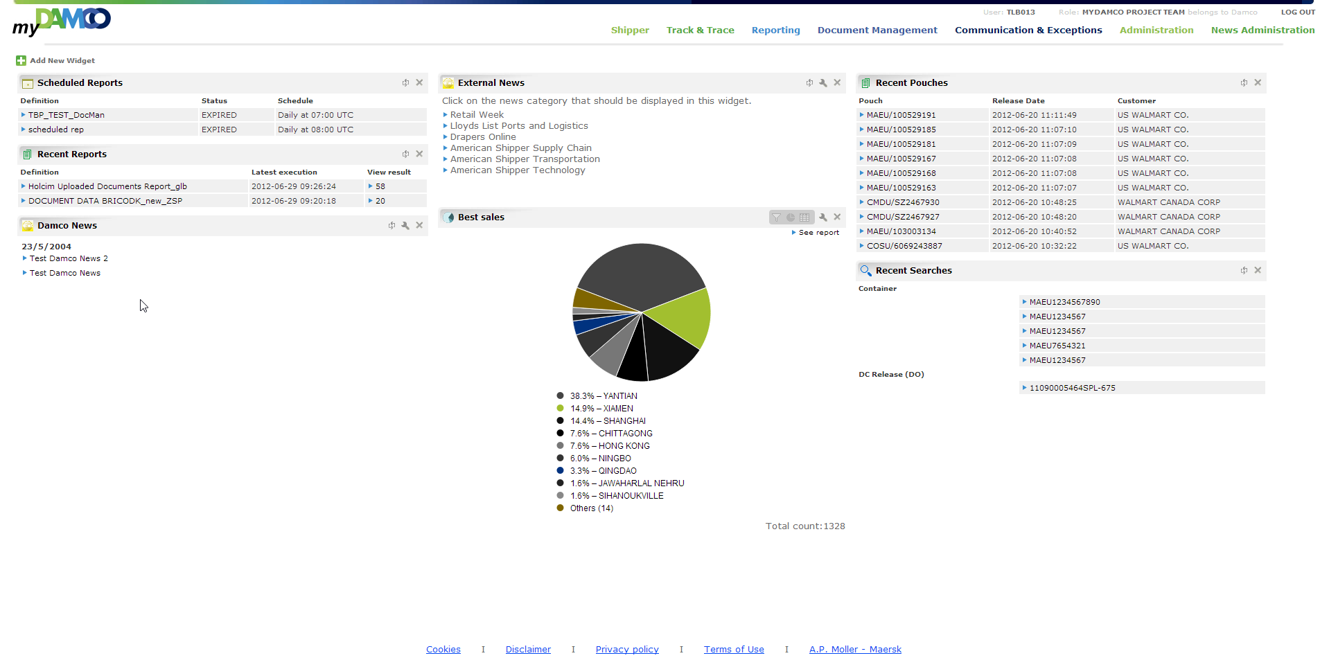

# Introduction

MyDamco is a web-based gateway into the Damco application landscape, for both customers and employees.

The purpose of this document is to provide a how-to guide for myDamco users. The guide is not intended for myDamco Administrators[1], Supporters[2] or Developers[3], but “normal” myDamco users.

This guide is created for myDamco version 4.4.1.

Contents

Introduction 2

1: Homepage 4

2: Navigation Menu 5

2.1 Navigating to other applications 5

2.2 Changing role 5

2.3 Profile 6

2.4 Returning home 6

3: Widgets 7

3.1 Widgets and caching 7

3.2 Adding a widget 7

3.3 Widget title bar 8

3.4 Available Widgets 9

3.4.1 The "Who Am I?" widget 9

3.4.2 The E-Learning widget 9

3.4.3 News widgets: Damco News and External News 9

3.4.3.1 Damco News 9

3.4.3.2 External News 10

3.4.4 Document Management widget 11

3.4.4.1 Recent Pouches 11

3.4.5 Reporting widgets 12

3.4.5.1 Recent Reports 12

3.4.5.2 Scheduled Reports 12

3.4.5.3 Recent Searches 12

3.4.5.4 Performance Chart 13

3.4.5.4.1 Basic Usage 13

3.4.5.4.2 Extended title bar 14

3.4.5.4.3 The pie chart 15

3.4.5.4.4 The ”Others” group 15

3.4.5.4.5 Advanced filtering 16

3.5 Required access rights 17

4: Administration 18

5: News Administration 19

6: Logout 20

# Homepage

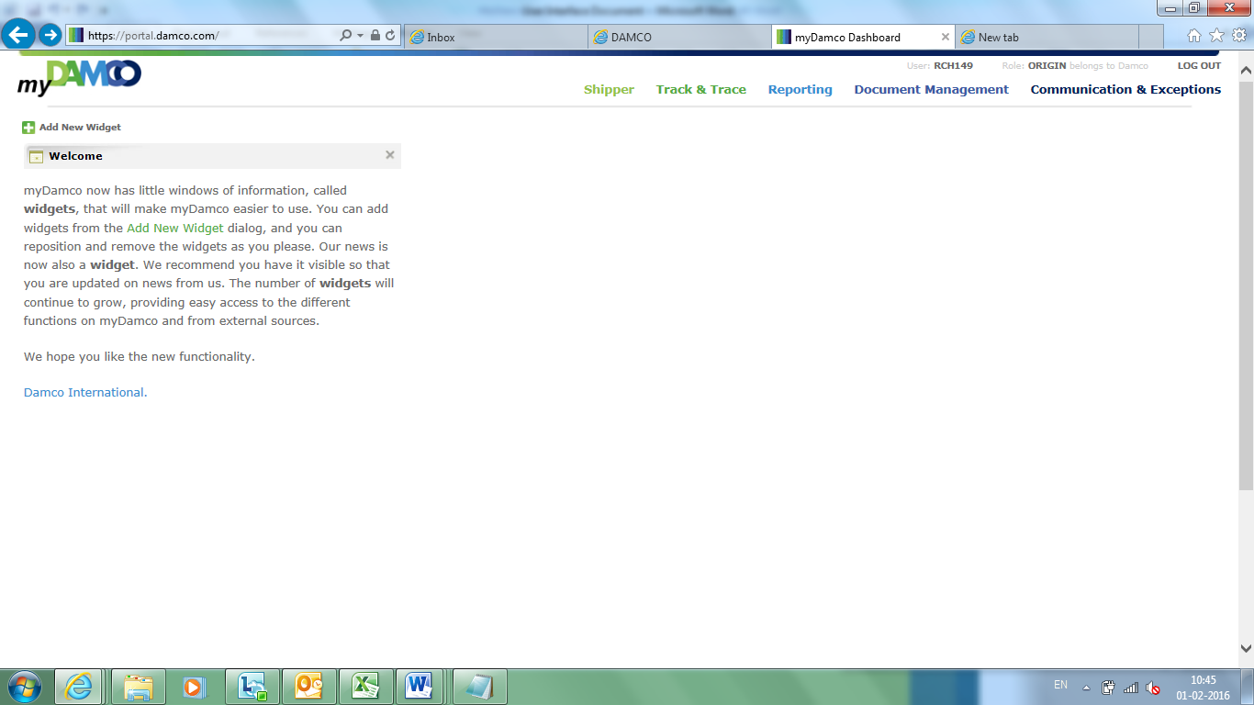

# Navigation Menu

The navigation menu is at the top of the screen. The menu provides a convenient means of navigating to other Damco applications, changing between your available UAM roles and more.



Figure 1: The navigation menu

## Navigating to other applications

The navigation menu shows links to other Damco applications. To navigate to an application, simply click its link. Exactly which applications you see in this list, depends on which applications you have access to (your UAM-role).

## Changing role

If you have multiple UAM-roles, you can also change role from the navigation menu. To change into another role, click the text stating your current role. This will open a dialogue allowing you to choose between all your available roles:

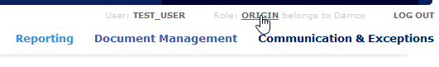

Figure 2: First, click your current role.

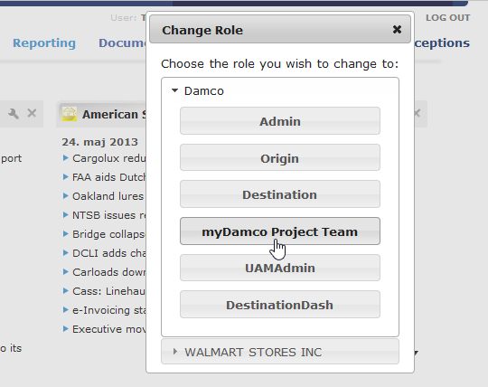

Figure 3: Then select the role you want to change into.

Please note that each of your different roles will have their own dashboard. In other words, you have one dashboard per role, with its own set of widgets, instead of only one dashboard in total.

## Profile

Clicking your account name, will bring you to your profile page. This page shows information about your profile and allows you to change your password.

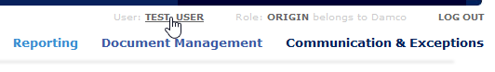

Figure 4: Click your user name to go to your profile page.

## Returning home

Finally, clicking the myDamco logo, will always take you back to your dashboard, no matter which application you are visiting.

# Widgets

Widgets are small windows you can place on your dashboard. Each widget shows different pieces of useful information, from news to available E-Learning courses. The widgets provide an overview of data from several different systems at one place – at your dashboard.

This section will start by explaining how to add widgets to your dashboard. After this, each widget in myDamco is described.

## Widgets and caching

For improving performance, the myDamco widgets are to a high extend based on cached data.

Recent Pouches, Recent Searches, Recent Reports and Scheduled Reports widgets are based on cached data. Damco News and Damco External News data are also cached.

This data is pulled from the source systems once every 900 seconds (15 minutes). This means a user’s behaviour, e.g. a recent search, will not automatically be updated in the widget for up to 15 minutes.

To override this cache mechanism, you can click the refresh button in the widget in order to get the newest data from the system. It is not enough to click F5/Refresh or the myDamco logo to get the data refreshed, you have to click the refresh icon of the widget.

The performance pie chart widget uses “classical browser caching” and myDamco does not cache any data to enhance performance here. The data is only stored locally in your browser. The refresh button refreshes the data from Reporting.

## Adding a widget

To add a widget to your dashboard, simply click "add widget" and drag the widget of your choice onto your dashboard.

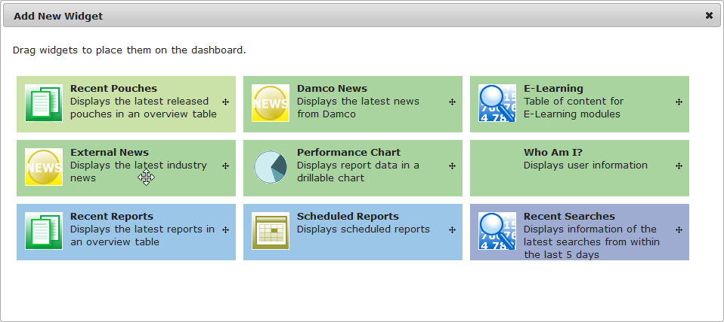

Figure 5: Drag a widget from the dialog and onto the dashboard to add it to your dashboard.

It is even possible to add the same widget twice. This can be useful if you want to display different information available from the same widget. For example, you could have two External News widgets (see below) at the same time, showing news from two different sites.

Which widgets are available to you, again depends on which systems you have access to (your UAM role). As an example, the widgets displaying information from the Reporting application will only show up if you have access to the Reporting application. (See section 3.4 for more information)

## Widget title bar

Before introducing each widget, let us briefly take a look at the title bars of widgets. All widgets have a title bar, showing the title of the widget, allowing you to drag it to a new location, close it and more. This is similar to the windows you are used to, so you should immediately feel at home with this.

With the title bar, you can freely drag a widget to a new location on your dashboard. The title bar also contains common buttons:



configure

refresh

close

Figure 6: Widget title bar and the common buttons.

All widgets have a close button, which removes the widget from your dashboard. Most widgets also have a refresh button, which refreshes the content of the widget. The refresh button overrides the cached data and ensures that you see fresh data instead of cached data.

In addition, some widgets have a configuration button (the wrench icon), which you can click to choose which information you want displayed in the widget.

## Available Widgets

There are a number of widgets you can place on your dashboard, and more will likely be created in the future. This section will help familiarize you with each of the currently available widgets.

### The "Who Am I?" widget

This basic widget simply displays your profile information, such as your name and address, etc. This is the exact same information that you see, when going to your profile page, but this time in a widget on your dashboard.

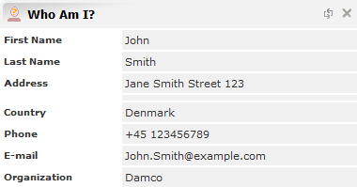

Figure 7: Example of the “Who Am I?” widget.

### The E-Learning widget

In the E-Learning widget, you will find various interactive tutorial videos to help you learn how to use certain features of the systems at Damco, for example. In the widget you are presented a list of available tutorials. Simply click one of them, to play the video.

### News widgets: Damco News and External News

There are two kinds of news widgets, to help keep you up to date with information of relevance to you. The Damco News widget shows internal news from Damco and the External News widget shows news from external sources.

#### Damco News

The Damco News widget displays internal news from Damco, as well as public news from damco.com. It is recommended to always have this widget on your dashboard, so that you will never miss an internal news update. On the first page, the widget will show the titles of the latest 10 news articles. If there are more than 10 articles available, you can press the “Older” button, to go to the next page. To read an article, simply click on its title.

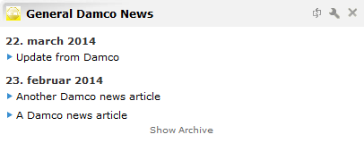

Figure 8: Example of the Damco News widget.

The Damco News widget will only show news articles which are currently “active”. You can however still see old articles, by clicking the “show archive” link at the bottom of the widget.

#### External News

The External News widget works in the same way as the Damco News widget. The difference is that instead of showing news internal to Damco, this widget shows news from a number of non-Damco sites.

When you first drag in this widget, you are presented a choice of which news feed you would like to be shown in the widget. After you have selected a feed, the latest news of that feed will be displayed. If you want to select a different feed at a later, simply press the configuration button (wrench) in the title bar and select the new feed you would like to have displayed. You can even have multiple widgets on your dashboard showing different feeds at the same time.

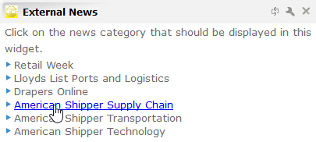

Figure 10: Start by selecting a news feed.

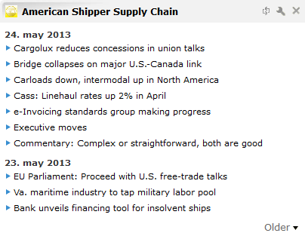

Figure 11: After having selected a feed, the widget now shows   
the articles from that feed.

### Document Management widget

If you have access to the Document Management application of Damco, the “Recent Pouches” widget is available to you, which will help you getting an overview of the latest released pouches.

#### Recent Pouches

This widget shows you the latest released pouches in an overview table. Each row of this table shows the pouch name, the release date and the customer. Clicking the pouch name, takes you to the corresponding page in the Document Management application.

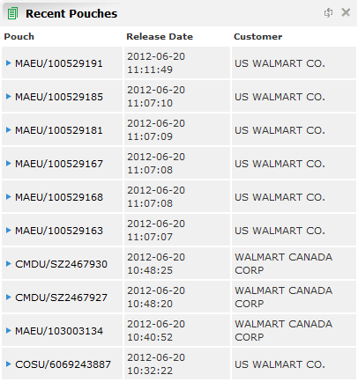

Figure 12: Example of the Recent Pouches widget.

### Reporting widgets

If you have access to the Reporting (incl. Track & Trace) application of Damco, there are up to four widgets you can place on your dashboard, to help you get an overview of your reports. (See section 3.4 for the exact requirements for a widget to be available).

#### Recent Reports

In this widget, you will see the list of most recent executions of your reports. For each item in the list, you will see the name of the report, the time of its execution and the number of results for that execution.

You can click the report name, to go directly to the report definition in the Reporting application. In addition, the result column will tell you the number of rows in the result of the execution. Clicking this number, will take you to the page showing the entire report result.

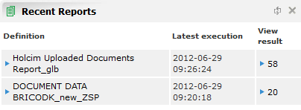

Figure 13: Example of the Recent Reports widget.

#### Scheduled Reports

This widget shows you the list of your report schedules from the Reporting application. For each item in the list, the report name is shown, the status of the schedule and finally when it is scheduled to run. Again, clicking the report name, brings you to the report definition.

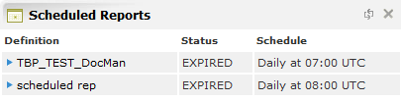

Figure 14: Example of the Scheduled Reports widget.

#### Recent Searches

In this widget, you will see the most recent searches you have made in the Reporting application, from within the last 5 days. You can click on a search to perform it again.

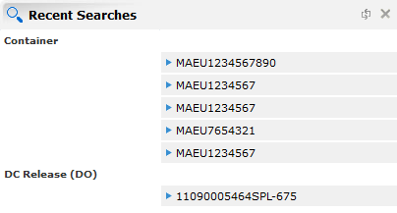

Figure 15: Example of the Recent Searches widget.

#### Performance Chart

The performance chart allows you to see a report in a more visual way, than the standard tabular format. This can help you get a better and faster overview of your report results. Furthermore, it provides an easy way of filtering your values by simply pointing and clicking.

##### Basic Usage

When you initially drag in the performance chart widget, you have to select which report to show in the widget. You can do this by writing the first couple of letters of the report name in the input field and then select it.

*Note that the available reports are the ones which have had their “Dashboard Graph” check box checked in the Reporting application. Also note that not all users have access to see this check box. It is also in the Reporting application you select which fields are visible in the widget.*

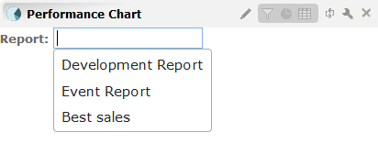

Figure 16: Selecting a report to show in the widget.

When a report is selected the report is visualized as a pie chart such as the one shown in the following figure:

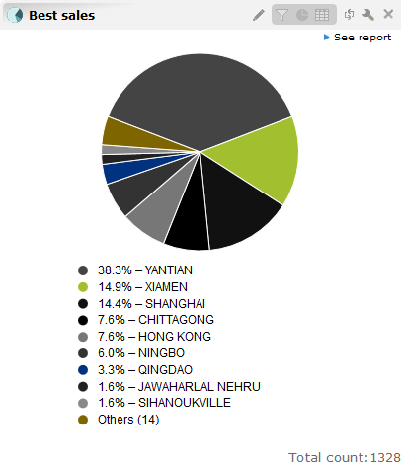

Figure 17: Example of a pie-chart visualization of a report.

##### Extended title bar

The performance chart widget has four additional icons in its title bar:



Tabular

view

Pie-chart view

Show

fields

Rename

Figure 18: Additional title bar buttons of the Performance Chart widget.

The rename button allows you to change the title of the widget. It only changes the title of your own widget, it will not affect anyone else, so feel free to rename it to anything you like.

The two rightmost of the new buttons are for changing between pie-chart and tabular view. As you have seen, the default is to visualize the data graphically as a pie chart, which is great for giving an overview of the data, but if you would like to have more detailed view of the data, you can have it displayed in a regular table as well.

The “Show fields” button, allows you to see the fields from the report, whose values are displayed in this widget. These are also the fields you can filter by, using the widget. Here in the beginning, to gain an intuition on how your report data relates to what is shown in the widget, it is recommended to click this button, so that these fields are shown.



1st field

2nd field

3rd field

Figure 19: Fields are being shown, after having clicked the “show fields” button.

When the fields are displayed, you can rearrange their order, by dragging and dropping them in the new order in which you wish them to be.

##### The pie chart

Provided you have clicked the “Show fields” button (described above), the fields of the report are visible at the top of the widget. The green field is the current field, and is the field whose values are represented in the pie-chart below it.

The pie-chart shows the distribution of the values of this field. The percentage (the size of a piece of the pie chart) associated with each value, is the percentage of rows in the report having the given value for this field (column).

Clicking a piece of the pie-chart, selects that value and displays the values of the next field (the next field becomes green), which are associated with the selected value. In other words, it filters the values of the second field by the selected value of the first field. *(Please note that the percentages which are now shown, are only calculated among those values which 'survives' the filtering by the selected value from the first field.)*

Clicking a piece of the pie-chart once more, will again go to the next field and the values from this third field will now be filtered by the selected values of the first two fields. That is, only values from the third field which are associated with the selected values in the two first fields are shown. You can continue in this manner, until there are no fields left.

As mentioned, you can rearrange the order of the fields. This allows you to filter the report data in a different order than the default order, by pointing and clicking.

Also notice, that you can click one of the fields displayed at the top of the widget to go to that field.

##### The ”Others” group

If there are more values for a field than there is room to show in the pie-chart, only the values with highest percentage are shown and the rest are grouped into an “Others” group. Clicking this pie-chart piece behaves differently from clicking the normal pie-chart pieces. Instead of going to the next field and filtering by the clicked value, it stays at the same field and shows the values inside the “Others” group. If there are still too many to show, those with lowest percentages are again grouped into an “Others” group. Clicking “Others” can thus be seen as going to the next page. (Note after you have clicked “Others”, the displayed percentages and pie-chart piece sizes, are only relative to the ‘page’ at which you are at now, and the following ‘pages’. The values in the previous ‘pages’ are not included.)

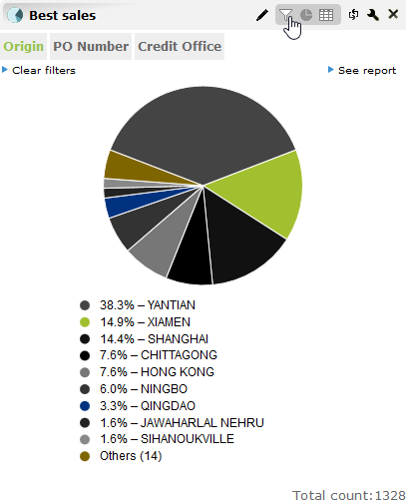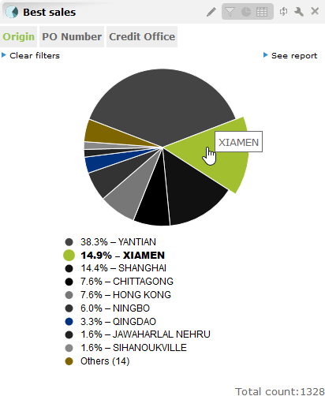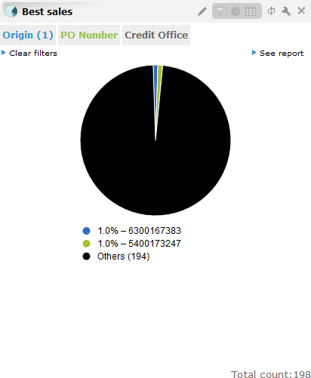

Figure 20: a) click the “show fields” button to show the fields, b - c) clicking a piece of the pie chart   
goes to the next field and filters the values in that field by the clicked value.

##### Advanced filtering

Up till now, we have seen how to filter the report by clicking the pieces of the pie-chart. This only allows to filter by a single value per field. If you want to filter by multiple values per field, that is possible too.

To do this, you must click the “Show fields” button, so that the fields are displayed, unless you have done so already.

When you hover your mouse pointer over a field name, a drop down box will appear, containing the list of values of that field. A check box is placed next to each value. Checking such check box corresponds to filter by the corresponding value. You can check multiple check boxes for the same field, and thereby filter by multiple values. What happens when you click a piece of the pie chart is actually that exactly one of these check boxes are checked.

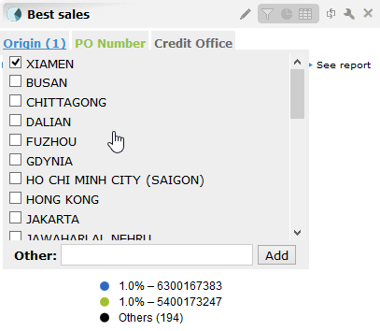

Figure 21: The drop down which allows you to filter by   
multiple values from the same field.

## Required access rights

In the previous section, each of the available widgets on My Damco were described. As mentioned, not all users have access to all of these widgets. In this section, it’s briefly summarized which rights are required to access each widget – i.e. which UAM-Application and UAM-Function you need in your UAM-Role in order to see a specific widget. These are the requirements:

| **Widget** | **UAM-Application** | **UAM-Function** |
| --- | --- | --- |
| Who Am I? | MYDAMCO | USE |
| E-Learning | MYDAMCO | USE |
| Damco News | MYDAMCO | USE |
| External News | MYDAMCO | USE |
| Recent Pouches | DOCUMENT_MANAGEMENT |  |
| Recent Reports | REPORTING_TRACKTRACE |  |
| Scheduled Reports | REPORTING_TRACKTRACE | REPORT_USER |
| Recent Searches | REPORTING_TRACKTRACE |  |
| Performance Chart | REPORTING_TRACKTRACE | REPORTING_DASHBOARD |

For the rows in which the UAM-Function field is empty, any right with the given UAM-Application will allow access.

# Administration

On selecting Role as ‘MYDAMCOADMIN’, user is able to see ‘Administration’ and ‘News Administration’ section.

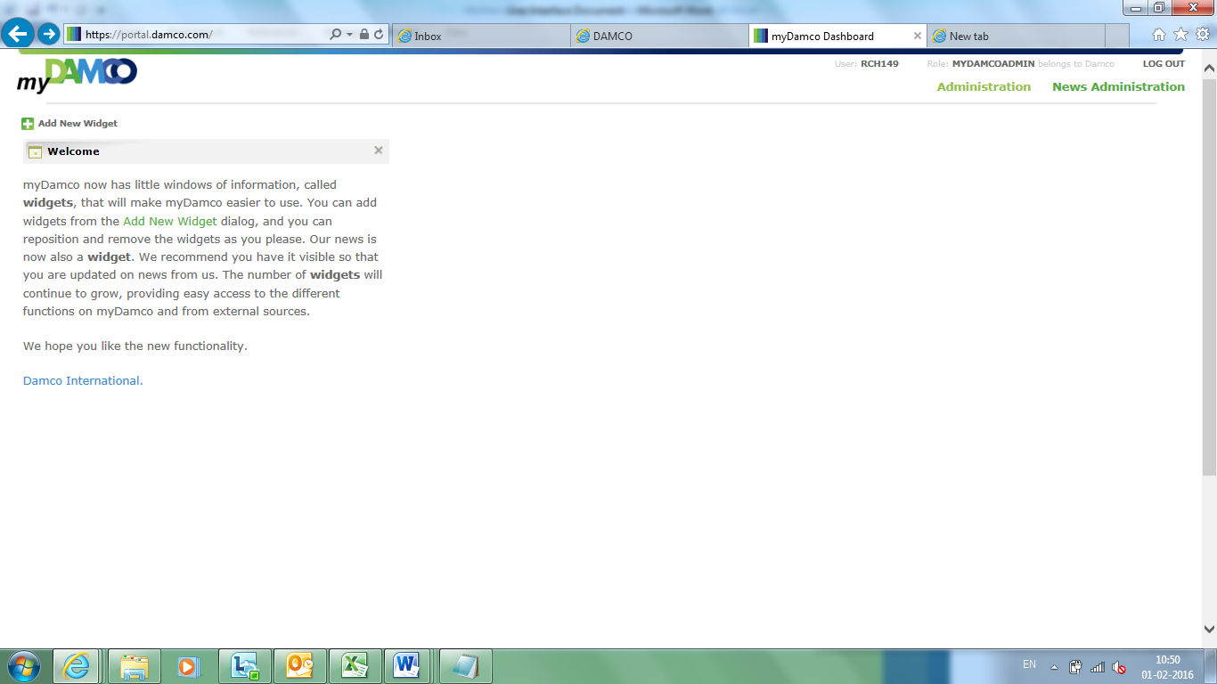

## News

In this section, administrator can set configurations for MyDamco Announcements, General News and categories.

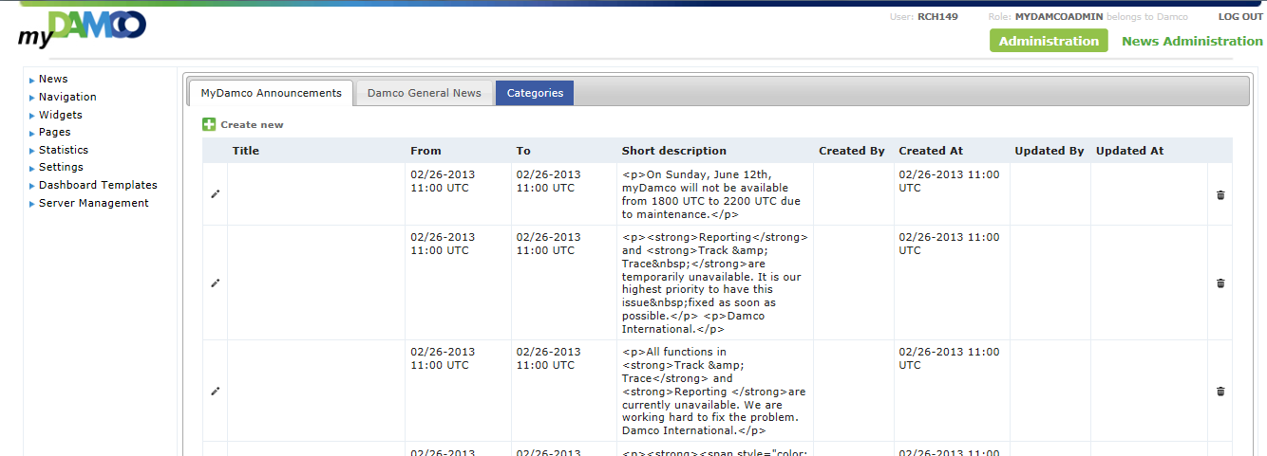

1. Administrator can add new announcement by clicking on ‘Create New’ icon.
2. Administrator can delete a particular announcement by clicking on delete icon for that row.
3. Administrator can edit the announcements, by clicking on edit icon. Edit window facilitates you to edit the description of the announcement. See snapshot below.

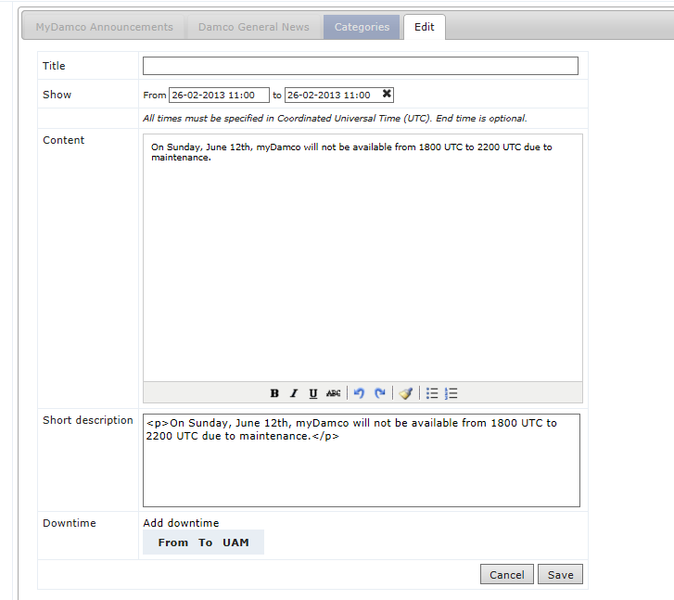

1. Same features are available for DAMCO general news/

## Navigation

In this section, administrator can set the configurations for applications available in navigation panel. Attributes that can be mainly configured are:

* **UID**: Id of the application as defined in the UAM
* **URL**: Application URL to which it navigates to.
* **Target**: Specifies whether application will be opened in myDamco portal itself (iFrame) or will redirect to the external application itself.
* **UAM** **Application**: Name of the application as defined the UAM.

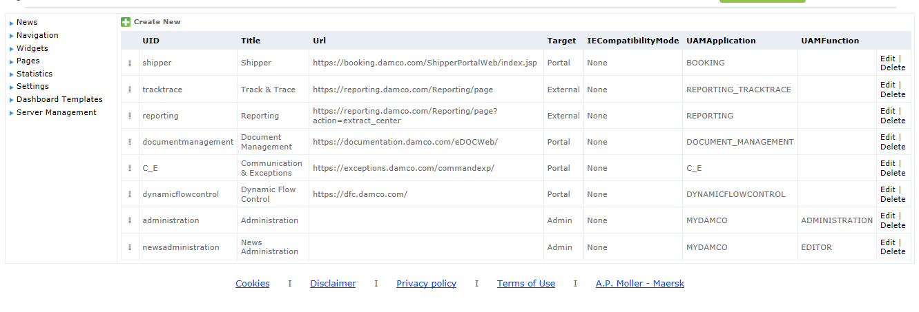

## Widgets

In this section, administrator can set the configurations for widgets available in dashboard. Attributes that can be mainly configured are:

* UId
* Title
* Icon
* ServiceURL
* Description
* Category
* RSSNews
* Configuration
* ConfigurationSchema
* ServiceConfiguration
* UAM

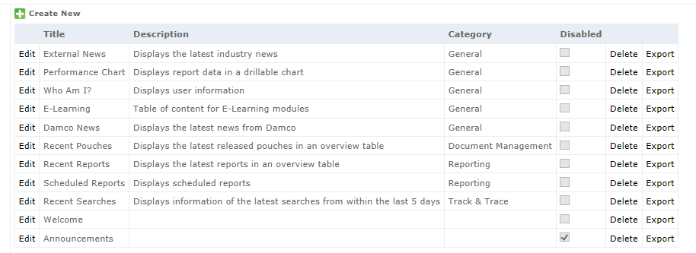

1. Administrator can add a new widget by clicking on ‘CreateNew’ icon.
2. Administrator can edit configurations for each widget using edit option.

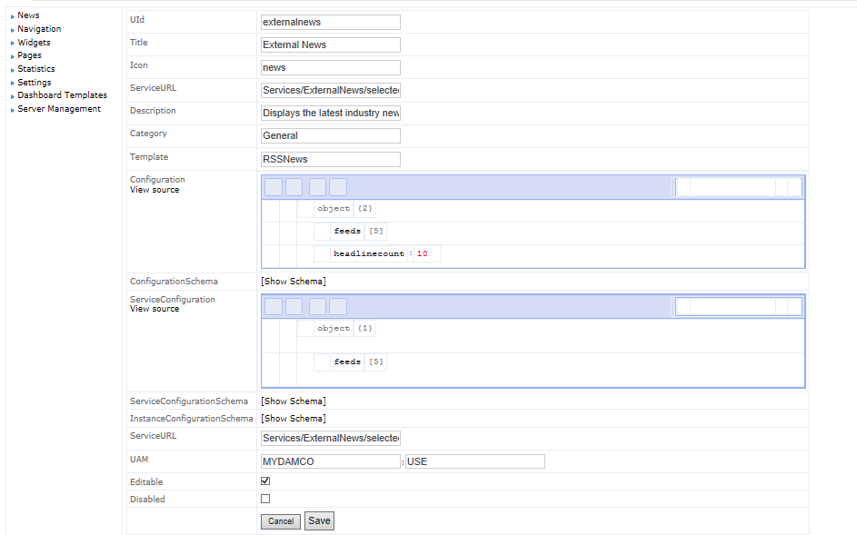

## Pages

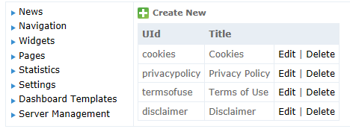

## Statistics

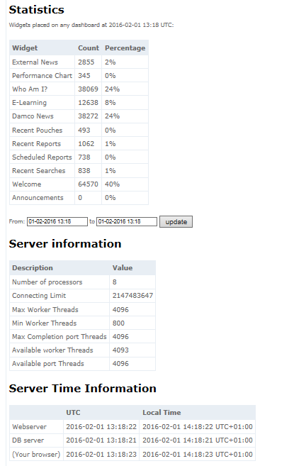

## Settings

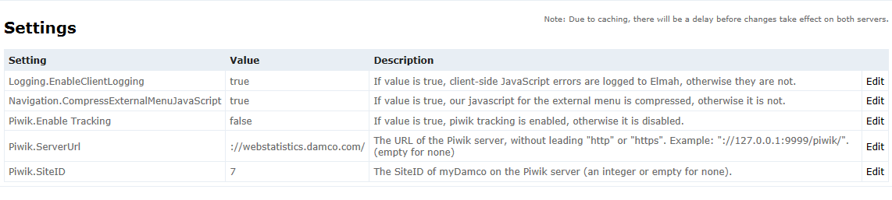

## Dashboard Templates

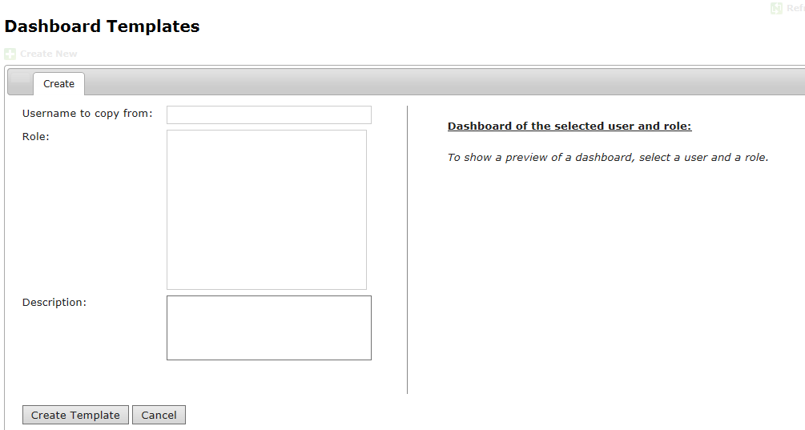

## Server Management

Administrator can view and delete the error logs occurred in the application. Also, this interface allows user to clear javascript files, css and image caching to enhance application performance.

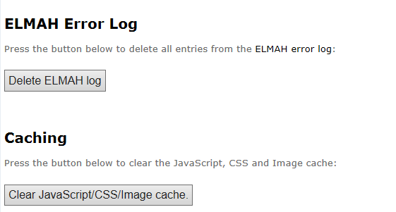

**ELMAH Error log page:**

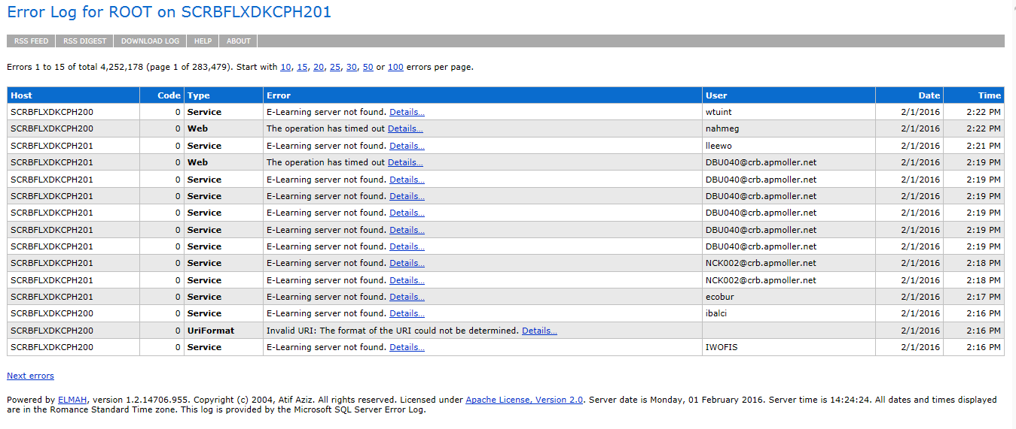

# Logout

In the top right corner, there is a log out button. When you click the log out button, a pop up is displayed, informing you that you should close the browser completely in order to log out.

1. Please refer to the Administrator guide.
2. As a supporter, you should probably know about this manual, but also make yourself familiar with the troubleshooting guide for myDamco.
3. Please also read the System Documentation document.